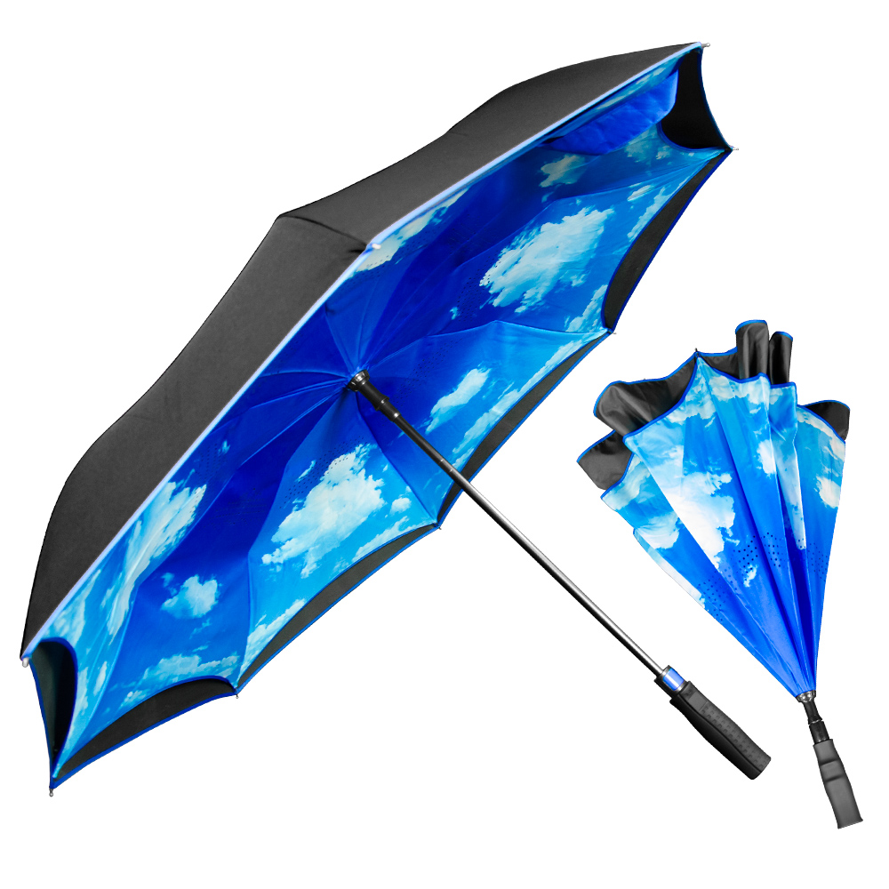
SB-4601

The Inversa Blue Sky & Clouds Inverted Umbrella

The auto-open Blue Sky & Clouds Inverted Umbrella is designed to not only protect you from the rain, but also from a rain-soaked umbrella. With a 48" arc, double-layer canopy, and all-fiberglass construction, this windproof umbrella closes in reversible fashion, keeping the wet side of the umbrella contained and away from you. The intelligent design also makes it easier to open and close from inside doorways and cars, so you stay dry from start to finish. This variation on our award-winning SB-4600 Inversa showcases lovely blue skies!

Arc Size: 48” Number Of Panels: 8

Diameter: 41” Length When Closed: 31”

Opening: Automatic Imprint Area: 6”H x 7”W

Shipping weight 24 pieces: 34 lbs. Box Dimensions: 32” x 14” x 14”


